**Hi,  
Please Provide us following details so that we may finalize the deployment on polygon mainnet:**

**Polygon Mainnet account Private Key or Real Matics are required:**

* To deploy the smart contract on production/mainnet, we will be needing the private key of the admin’s metamask wallet which contains real matics.
* Or if the admin doesn't want to share that, we will be needing some real matics to deploy the contract from our account and then give the permanent ownership to the admin’s account. Still, the admin's private key will be required as we have to allow some functions from the backend which will be needing the private key to sign the transactions.
* All the access for admin privileges will be provided to that admin/owner account
* Max mint count has been set to "up to 5 mints" in the contract... The admin can set any number of mints up to 5.

**NFT-ES Polygon Mainnet QuickNode Endpoint:**

Please purchase us the required Endpoints for NFT-ES Project Mainnet Deployment:

Here is a complete guide how to do it:

1. Please login to Quicknode at <https://www.quicknode.com/endpoints>
2. Create Endpoint

1. Select Polygon
   1. Select Mainnet

1. For now, we are going with simple plan, but if needed we may add some ad-ons but it depends upon our needs. So,
   1. Continue

1. Select “Launch” PlanA screenshot of a computer

   Description automatically generated
2. Provide Credit card information
3. Pay and Create.
4. Please send the API Endpoint URLs.

**Missing Language Translations:**

**Admin side language tranlation missing**

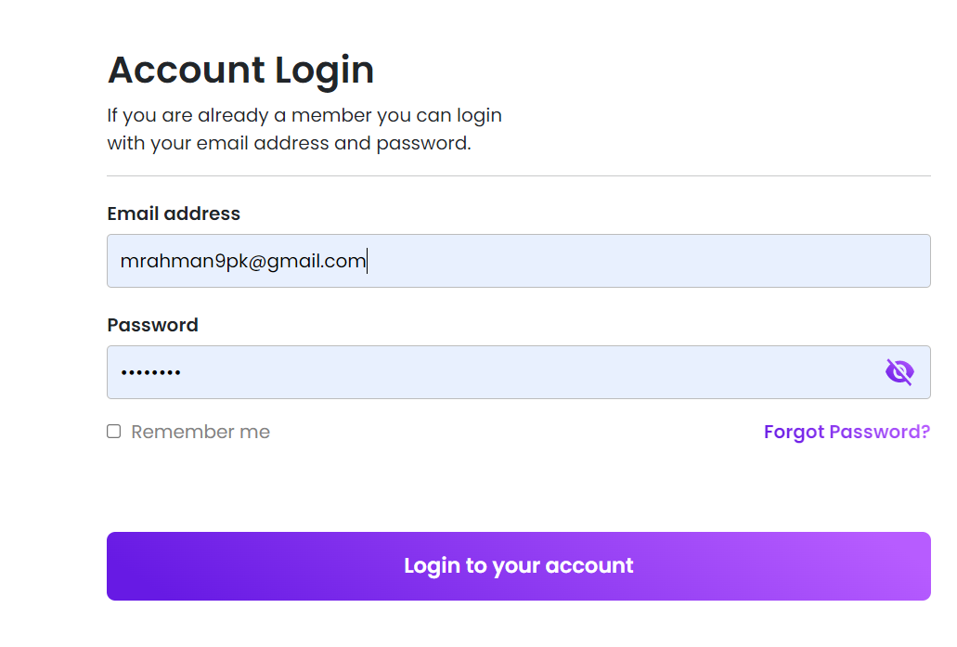

|  |  |  |
| --- | --- | --- |
| Screen | Text (English) | Text (Spanish) |
| Admin login | Account Login |  |
| If you are already a member you can login with your email and password |  |
| Email Address |  |
| Invalid email |  |
| Password |  |
| Wrong password |  |
| Forgot Password |  |
| Remember me |  |
| Login to your account |  |
| Loading |  |

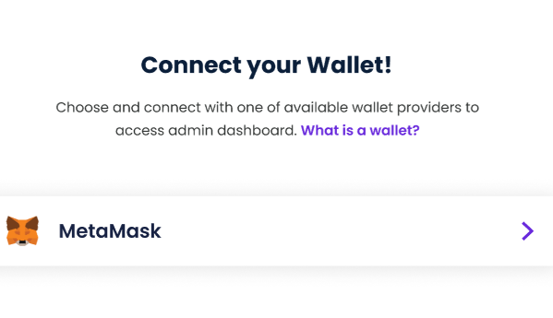

|  |  |  |
| --- | --- | --- |
| Screen | Text (English) | Text (Spanish) |
| Connect your Wallet | Connect your wallet |  |
|  | Choose and connect with one of the available wallet providers to access admin dashboard. What is wallet? |  |
|  | You cannot process account without meta mask connection .found meta mask connection error |  |
|  | You cannot access anything with this metamask account |  |

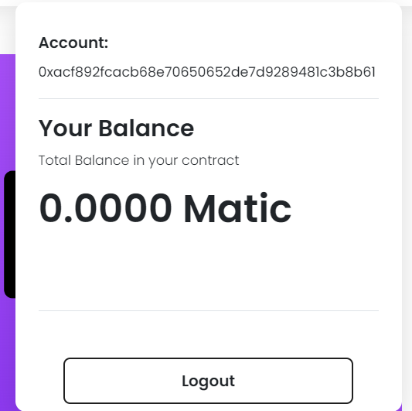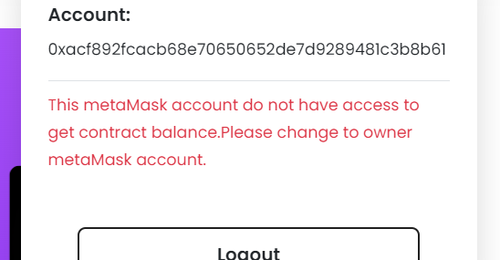

|  |  |  |
| --- | --- | --- |
| Screen | Text (English) | Text (Spanish) |
| Admin Account | Account |  |
| Your Balance |  |
| Total Balance in your contract |  |
| Logout |  |
|  | This meta Mask account do not have access to get contract balance . Please change to owner meta Mask account |  |

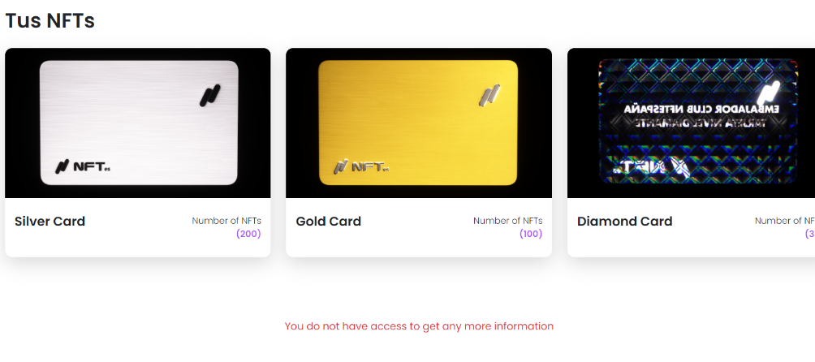

|  |  |  |
| --- | --- | --- |
| Screen | Text (English) | Text (Spanish) |
| Admin Backoffice | Number of NFTs |  |
|  | You do not have access to get any more information |  |
|  | Silver |  |
|  | Gold |  |
|  | Diamond card |  |

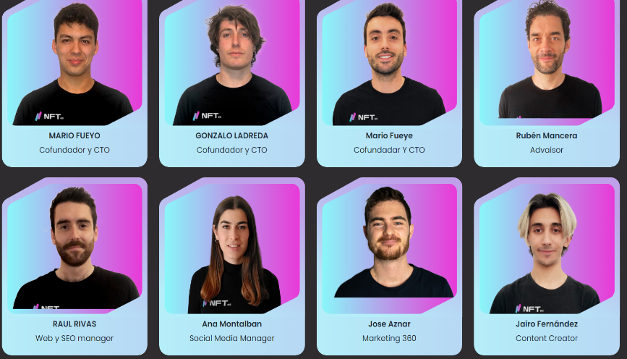

|  |  |  |
| --- | --- | --- |
| Screen | Text (English) | Text (Spanish) |
| Admin Backoffice(Team) | Advisor |  |
|  | Web SEO Manager |  |
|  | Social media Manager |  |
|  | Marketing 360 |  |
|  | Content writer |  |

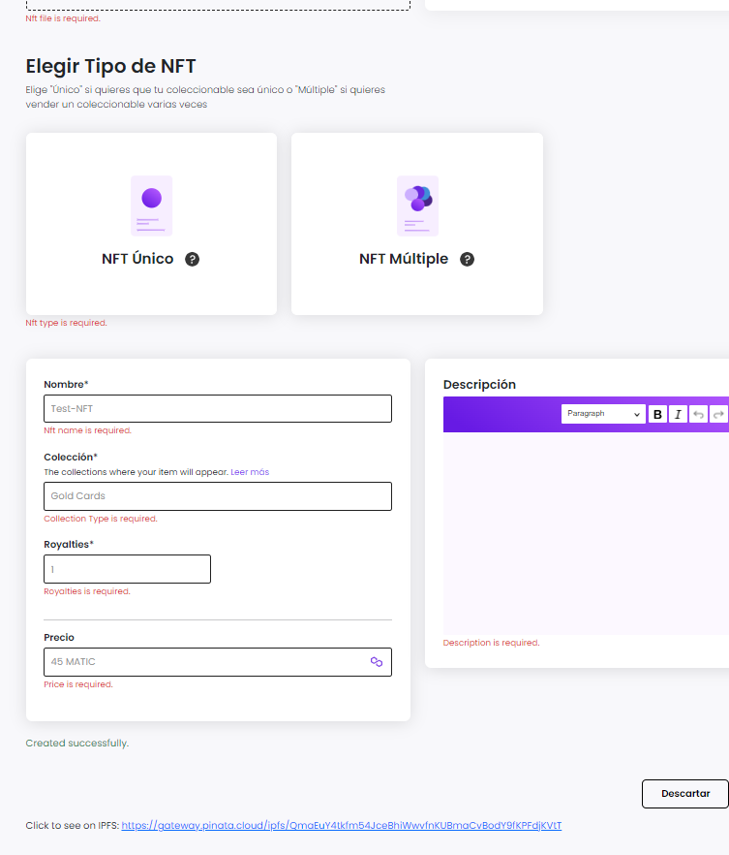

|  |  |  |
| --- | --- | --- |
| Screen | Text (English) | Text (Spanish) |
| Create NFT | NFT file is required |  |
|  | NFT type is required |  |
|  | NFT name is required |  |
|  | Collection Type is required |  |
|  | Royalties is required |  |
|  | Price is required |  |
|  | Description is Required |  |
|  | Created successfully |  |
|  | Click to see on IPFS |  |
|  | Please wait |  |
|  | NFT uploaded successfully |  |
|  |  |  |

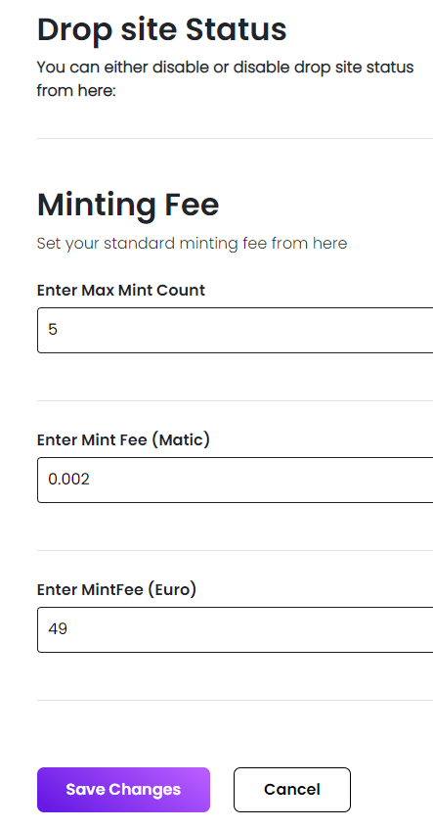

|  |  |  |
| --- | --- | --- |
| Screen | Text (English) | Text (Spanish) |
| Settings | Drop site status |  |
|  | You can either disable or enable drop site status from here : |  |
|  | Minting fee |  |
|  | Set your standard minting fee from here |  |
|  | Enter Max Mint Count |  |
|  | Enter Mint Fee(Matic) |  |
|  | Enter Mint fee (Euro) |  |
|  | Save changes |  |
|  | cancel |  |
|  | Enter standard max mint count |  |
|  | Enter standard minting fee |  |
|  | Loading |  |

**User end**

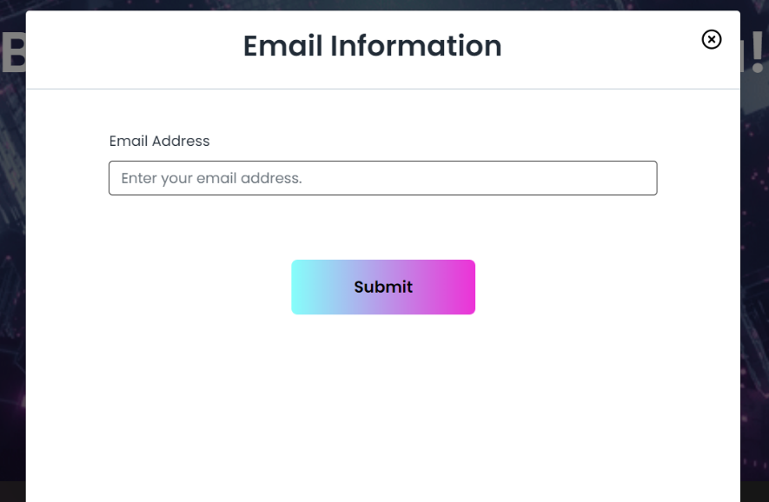

|  |  |  |
| --- | --- | --- |
| Screen | Text (English) | Text (Spanish) |
| NFT-es Drop site | Email information |  |
|  | Email Address |  |
|  | Enter your email address |  |
|  | Submit |  |
|  | Enter valid email |  |

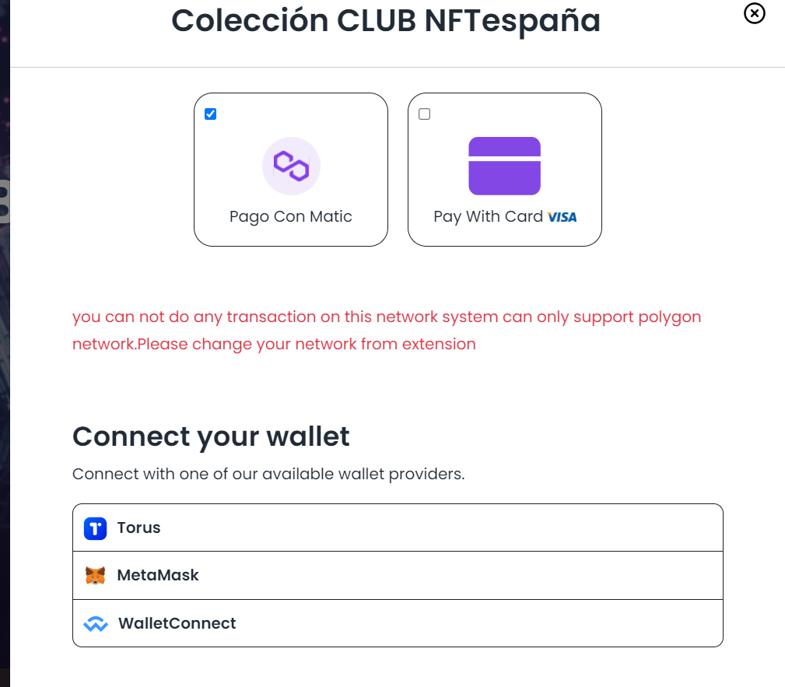

|  |  |  |
| --- | --- | --- |
| Screen | Text (English) | Text (Spanish) |
| NFT-es Drop site | Connect your wallet |  |
|  | Connect with one of our available wallet providers |  |
|  | You cannot do any transaction on this network system can only support polygon network .Please change your network from extension |  |
|  | Torus wallet disconnected successfully |  |
|  | Meta Mask wallet disconnect successfully |  |
|  | Login to you account |  |
|  | You have insufficient balance to continue this transactions |  |
|  | Login to your meta mask account to get your NFT-es |  |
|  | Connect your Meta Mask account remotely |  |
|  | Meta Mask account |  |
|  | Meta mask address |  |
|  | Continue to perform this transaction after successful transaction you will receive an email on( test@test.com) |  |
|  | If you do not have yet installed meta mask extensions you can find on this link |  |
|  | Waiting for payment |  |
|  | Creating Payment link |  |
|  | Partners |  |

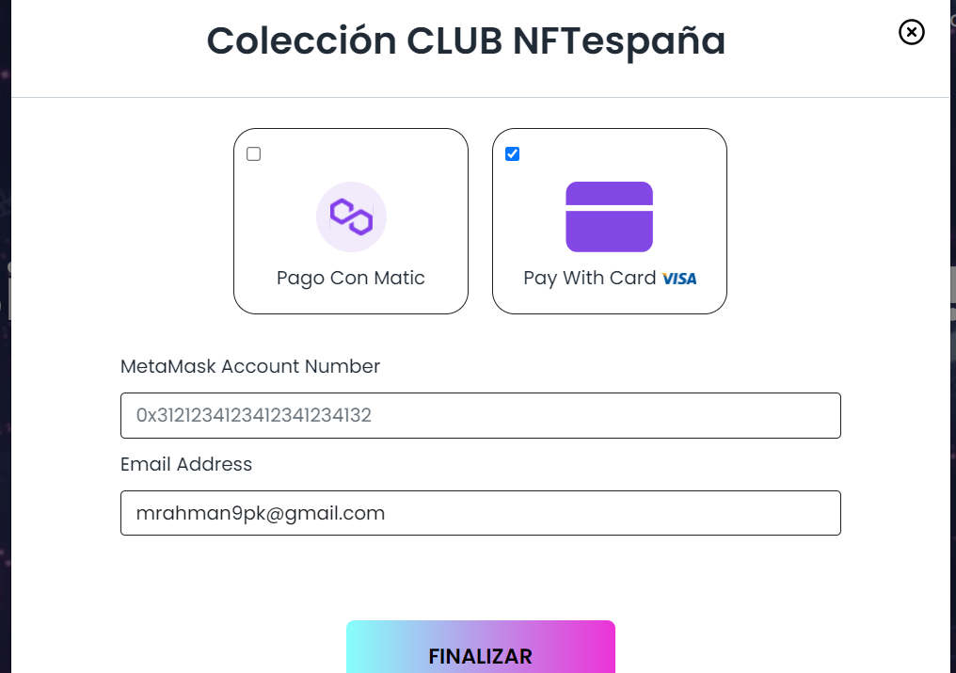

|  |  |  |
| --- | --- | --- |
| Screen | Text (English) | Text (Spanish) |
| NFT-es Drop site | Meta Mask Account number |  |
|  | Email Address |  |
|  | Creating payment link |  |
|  | Copy to clipboard |  |
|  | Email is not valid |  |
|  | Enter valid meta mask address |  |

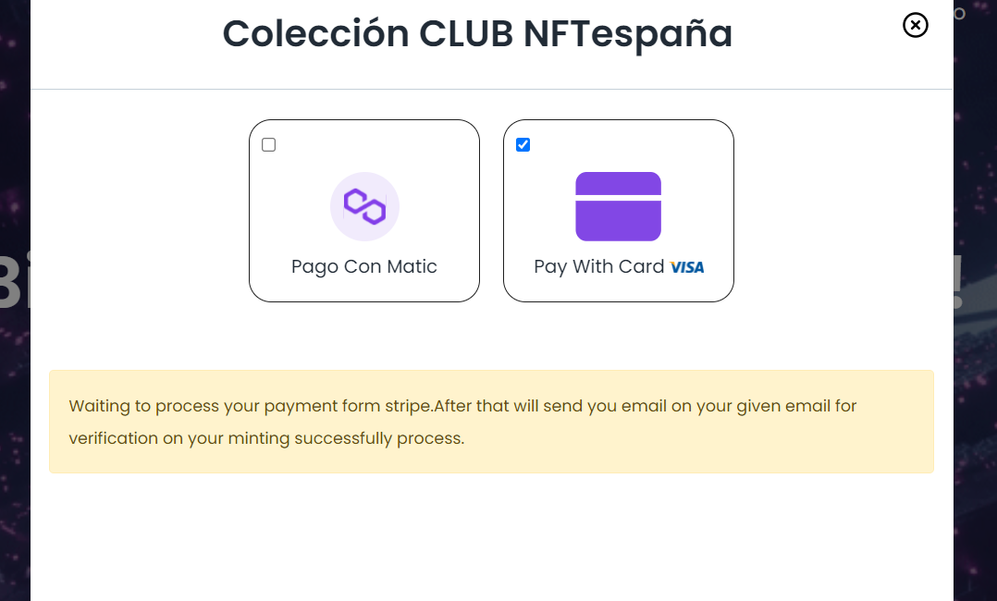

|  |  |  |
| --- | --- | --- |
| Screen | Text (English) | Text (Spanish) |
| NFT-es Drop site | Waiting to process your payment from strip after that will send you email on your given email for verification on your minting successfully process |  |

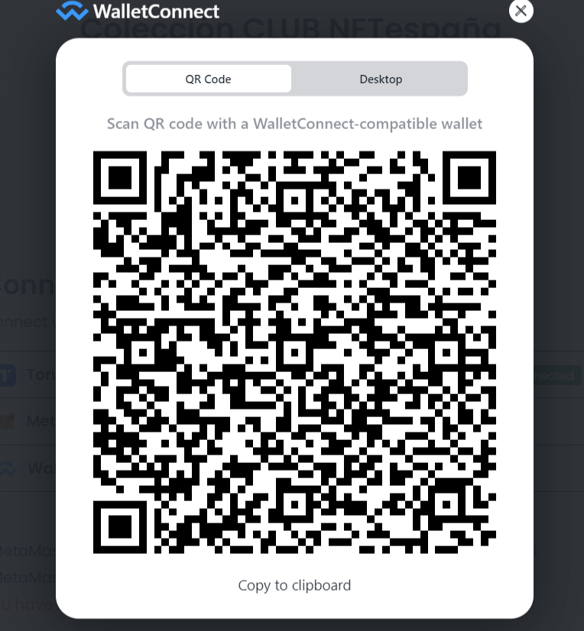

|  |  |  |
| --- | --- | --- |
| Screen | Text (English) | Text (Spanish) |
| Wallet connect QR code scan | QR code |  |
|  | Desktop |  |
|  | Scan QR code with a wallet Connection -compatible wallet |  |
|  | Copy to clipboard |  |